Munster Technological University

Title
Student Name: Parag Soni
Student No: R00208553

Time Series & Factor Analysis

Master of Science in Data Science & Analytics, Department of Mathematics, 20th May 2022

Student Examination Declaration

I, Parag Soni, hereby declare that the work submitted is my own. I declare that I have not obtained unfair assistance via use of the internet or a third party in the completion of this examination.

I acknowledge that the Academic Department reserves the right to request me to present for oral examination as part of the assessment regime for this module.

I confirm that I have read and understood the policy and procedures concerning academic honesty, plagiarism and infringements.

I understand that where breaches of this declaration are detected, these will be reviewed under CIT’s policy and procedures concerning academic honesty, plagiarism and infringements, as well as any other Institute regulations and policies which may apply to the case. I also understand that any breach of academic honesty is a serious issue and may incur penalties.

Time Series & Analysis

In this part of assignment we are going to perform Time series forecasting and analysis on a given dataset named "household_power_consumption.txt”. It contains 2,075,259 measurements gathered from a house located in Sceaux (7km of Paris, France) between December 2006 and November 2010 (47 months). The measurements of the household are taken with a one-minute sampling rate over the almost 4 years period.

The goal of the time series problem is to analyse the Time Series of the monthly average global active power consumption using R programming.

The analysis in 4 sections
- Data cleaning and manipulation
- Preliminary analysis
- Time series modelling
- Forecast
Data cleaning and manipulation

As part of this section we have performed two operations
- Handling Null or missing values using interpolation of previous and posterior observations.
- Create a new variable for the global active powzer representing the monthly average consumption.

Handling Missing Values:
We will be exploring only one variable and will check for missing values. The variable we will be exploring is “Global_active_power”. I used built in function Is.na () to check for null and found that there are total 25979 missing values in a global active power feature. To deal with found missing values later I used interpolation of previous and posterior observations.
After imputing missing values next is creating a new variable monthly_avg_consumption. For that I merged columns date and time to form timestamp and later aggregating monthly power variable stored in a new data frame.

Preliminary analysis

The given dataset household_power_consumption.txt contains total of 9 variables and has only one numeric variable named “Sub_metering_3” rest all are of type character.
List of variables is shown below:
Variable | Type
Date | Character
Time | Character
Global_active_power | Character
Global_reactive_power | Character
Voltage | Character
Global_intensity | Character
Sub_metering_1 | Character
Sub_metering_2 | Character
Sub_metering_3 | Numeric

Our main focus is on the variable named “global_active_power”. For that I have created a dataset containing this variable and the month. Summary statistics of the created dataset is shown below.

Group.1 | Global_active_power
Min. :2007 | Min. :0.2765
1st Qu.:2008 | 1st Qu.:0.9661
Median :2009 | Median :1.1230
Mean :2009 | Mean :1.0993
3rd Qu.:2010 | 3rd Qu.:1.2800
Max. :2011 | Max. :1.9013

Times series graph and bar plot of the above created dataset which will evaluate monthly_avg_consumption in Sceaux between December 2006 and November 2010 is shown below:
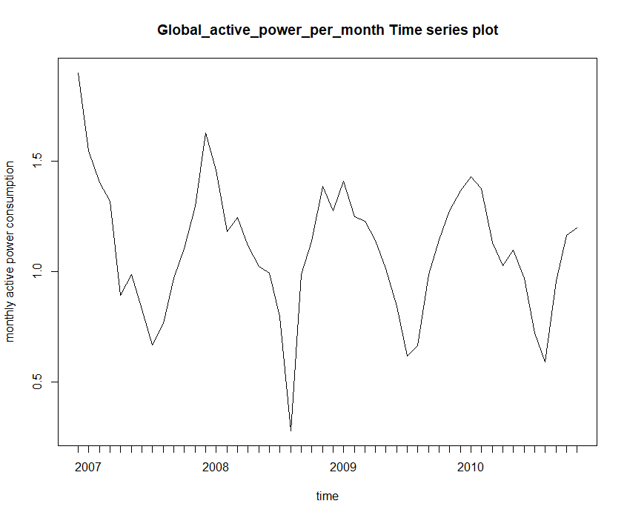
It is seen from the above plot that power consumption has a descending pattern. At the end of every year, power consumption is high and it gets low during the couple of month in the start of every year. A drop in the year 2008 also looks very steep or in other words the power consumption is very low. There is clear trend and seasonality in the dataset.
Summary of Global_active_power:
summary(Global_active_power_per_month $Global_active_power)
Min. 1st Qu. Median Mean 3rd Qu. Max.
0.2765 0.9661 1.1230 1.0993 1.2800 1.9013
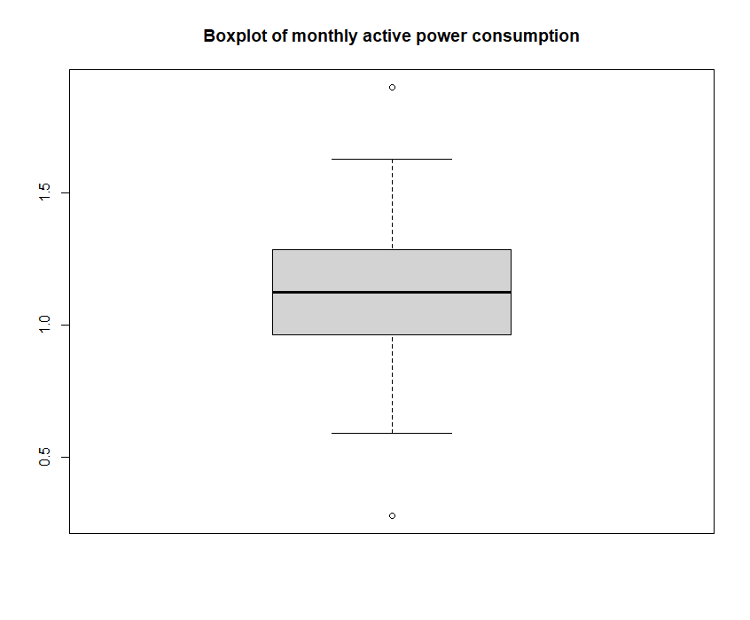
In this Box plot we can see that there are 2 outliers and the mean power consumption is 1.0993.

Next we convert the dataset in time series component to proceed with further time series analysis.
After converting dataset to time series we see below time series format:

Now we decompose the time series
Decomposition of Time Series
Next we decompose the time series using decompose() function and plot the decomposed dataset.
Below we can see the decomposition of the timeseries for additive model and multiplicative model:
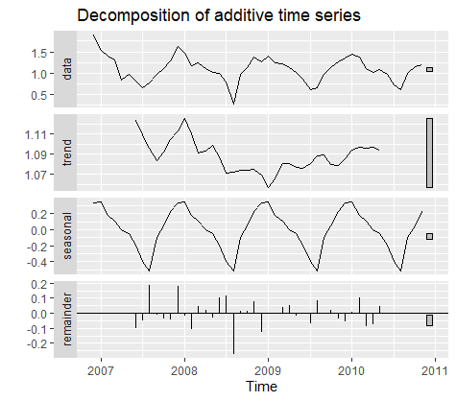

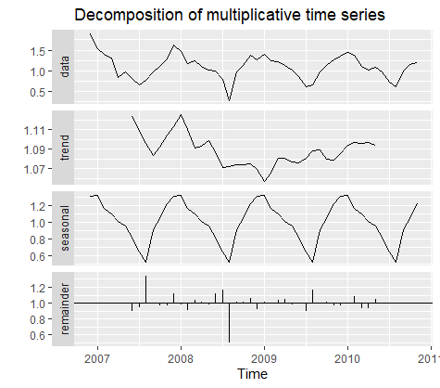
It is now clear from the plots that time series has trend and seasonality component present in it.
We will choose a model whose remainder mean is 0 because 0 mean models are assumed to be independent and identically distributed and represent random noise around fixed mean, which has been deducted from the time series as a constant terms.
In additive model, remainder has been observed as mean of 0 and in multiplicative model remainder has mean of 1. Thus, additive model is more suitable for this given time series.
In order to find the strongest component we check the vertical bars at the right most side of the decomposed plot. The component which has smallest bar is considered as strongest component. From above plot 3, it is seen that scale or the size of vertical bar of seasonal component is the smallest, meaning it varies more throughout the time series and thus we can say that seasonal component has strongest impact on the time series.
The periodicity is number of time periods that occur during the completion of a seasonal pattern and is also referred to as the series periodicity. Since the data is yearly the periodicity of the dataset is 12 which the number of months. Periodicity doesn’t effect the time-series in any way however it can an idea on how many data points are required before it is possible to develop time series forecasts. There are enough data point to forecast.
Next for forecasting we need to remove the seasonal component and obtain seasonally adjusted data for prediction.
Two steps in removing the seasonal component of the series:
Step 1 →remove the trend from the original series
Additive model: At – Tt
Multiplicative model: At / Tt
Step 2 →find the index for seasonal variation for each period.
for this the Mean value is computed for each period (i.e. quarter) and then normalized to add to 0 (additive) or p (multiplicative). Then we can find the time series with no seasonal effect by removing the index for each period to the original observations, depending on the type of model
(A – Seasonal Index or A / Seasonal Index).
OG data = trend +seasin+ error
Remove seasonal we get seasonally adjusted TS
And – error = trends

Time series modelling
Classical Model
Since the given timeseries has trend and level/seasonality component both, Holt’s winter method will more probably be suitable for describing this type of timeseries.
Fitting both additive and multiplicative model on the timeseries.

Performance Matrix | Additive Model | Multiplicative Model
AIC Score | 5.321519 | 22.50098
RMSE | 0.1070633 | 0.1051707
MAPE | 8.934935 | 8.682635

Above table compared the results of both models by the observed values for AIC, RMSE, and MAPE scores. We can conclude from the above information that additive model has low AIC, RMSE and MAPE as compared to multiplicative model and hence we can conclude that additive model is a better fits for our timeseries.
The result we found is consistent with what we expected in the preliminary analysis.

Stationarity Test:
A stationary TS is one whose properties do not depend on the time at which the series is observed (NO trend NOR seasonality). A time series is said to be stationary when the following conditions are satisfied:
1. Mean is constant and does not depend on time.
2. Auto covariance function depends on s and t only through their difference |s-t| (where t and s are moments in time)
3. The time series under considerations is a finite variance process.

To check the timeseries data is stationary or not, we can do that in R programming by performing Dickey-Fuller Test.
The output is shown below:

> adf.test(power_ts, alternative = "stationary",k = 0)
Augmented Dickey-Fuller Test
data: power_ts
Dickey-Fuller = -3.4146, Lag order = 0, p-value = 0.065
alternative hypothesis: stationary

Since the p-value(0.065) is not less than significance level (0.05), we fail to reject the null hypothesis and conclude that the given timeseries data is not stationary.
To make it stationary we remove variability first by performing log transformation on time series data. The plot looks like below:
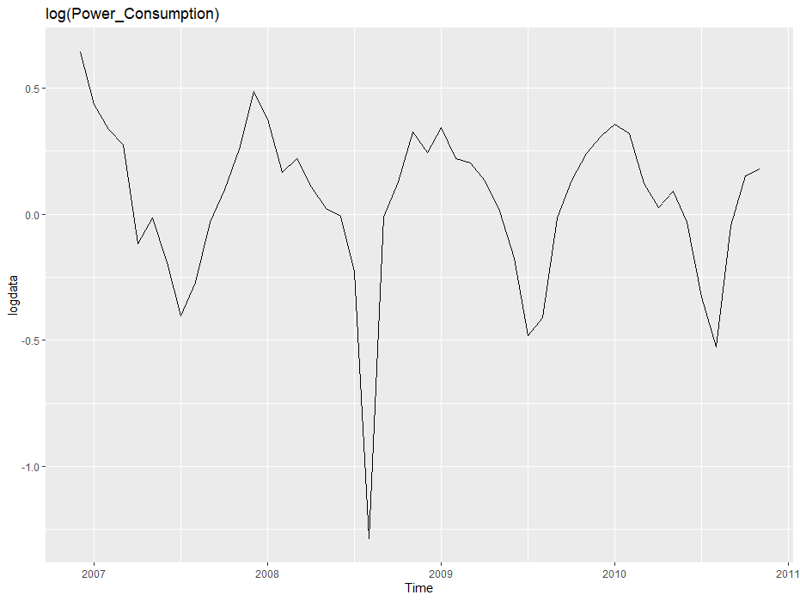
Next performing differentiation on the above log transformed data in order to remove trend. Plot is shown below:
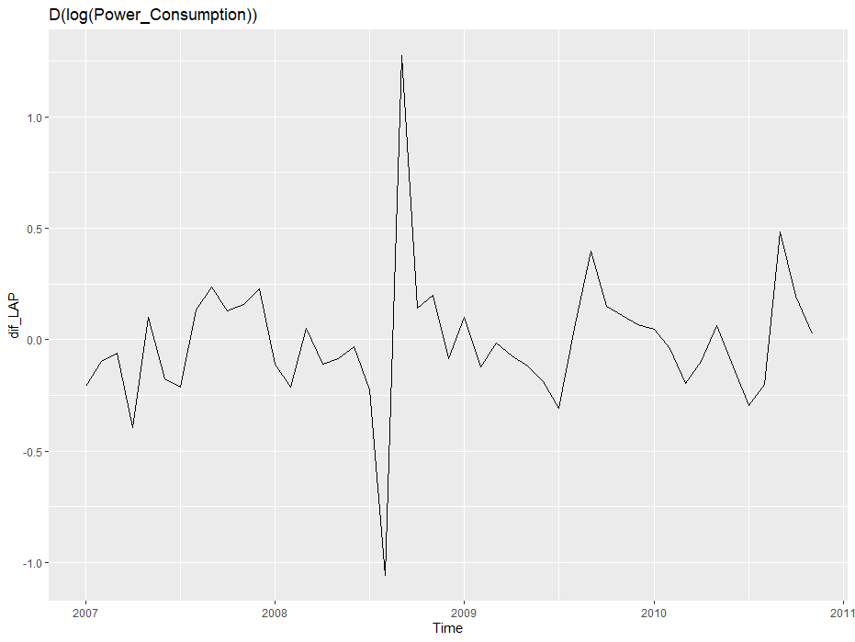
We again performed differentiation on the above differentiated data in order to remove seasonality.
Plotting decomposed additive time series.
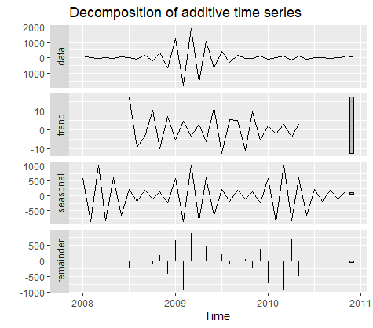
To make a series trend stationary we can create a new series by differentiating the original. After differentiating twice, we obtained data shown above.
We will again perform stationarity test. Output shown below:
Augmented Dickey-Fuller Test
data: dif_ses
Dickey-Fuller = -32.741, Lag order = 0, p-value = 0.01
alternative hypothesis: stationary

Now the p-value (0.01) is less than 0.05 and hence we reject null hypothesis and conclude that data is stationary. Next we can pass this data to auto.Arima() function.

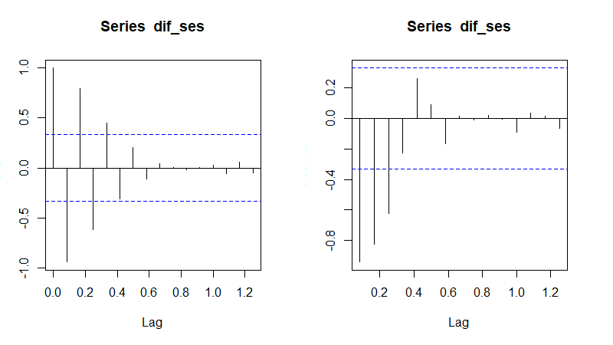
Above plot show ACF and PACF with the help of which we can identify the model.
ACF – auto correlation function – direct and indirect effect
Pacf – partial auto correlation function - direct effect
Horizontal line called Bartlett line in the above plots shows significant threshold value. Any basr that is above this line is said to be significant line. And the number of significant lines tells us which model it is.
Both ACF and PACF show slow decay (gradual decrease). Hence. ARMIA (3,1,1) could be candidate for this data series.
Next We fit the data with the models ARMA (1,1), ARIMA(3,1,1) and MA (3) models and observed the residuals.

After this we have performed auto.arima() function on the above decomposed time series dataand obtained below results:

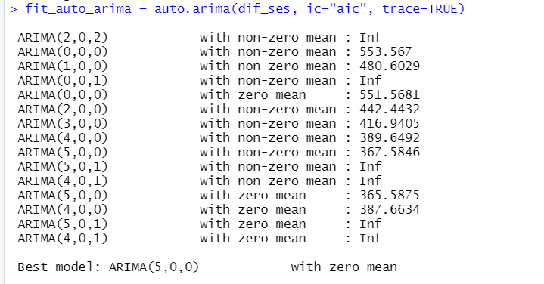

Printing fit_auto_arima
Series: dif_ses
ARIMA(5,0,0) with zero mean
Coefficients:
ar1 ar2 ar3 ar4 ar5
-3.4978 -5.6183 -5.2162 -2.7878 -0.6780
s.e. 0.1095 0.3268 0.4369 0.3142 0.1023
sigma^2 = 1093: log likelihood = -176.42
AIC=364.85 AICc=367.85 BIC=374.18

We observe that the best model obtained is ARIMA (5, 0, 0) with lowest AIC Values of 367.85 and 0 mean residuals.

Below is the plotted ARIMA (5, 0, 0) model with 0 mean containing time series plot, ACF-PACF and residuals histogram by using “checkresiduals” function on the “fit_auto_arima” model.
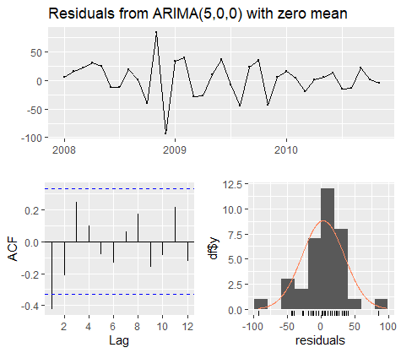

We see that the residuals are normally distributed and can say that there is no correlation between the residuals.
Plotting 2 other ARIMA Model than the ARIMA (5, 0, 0).
- ARIMA(0, 0, 0)
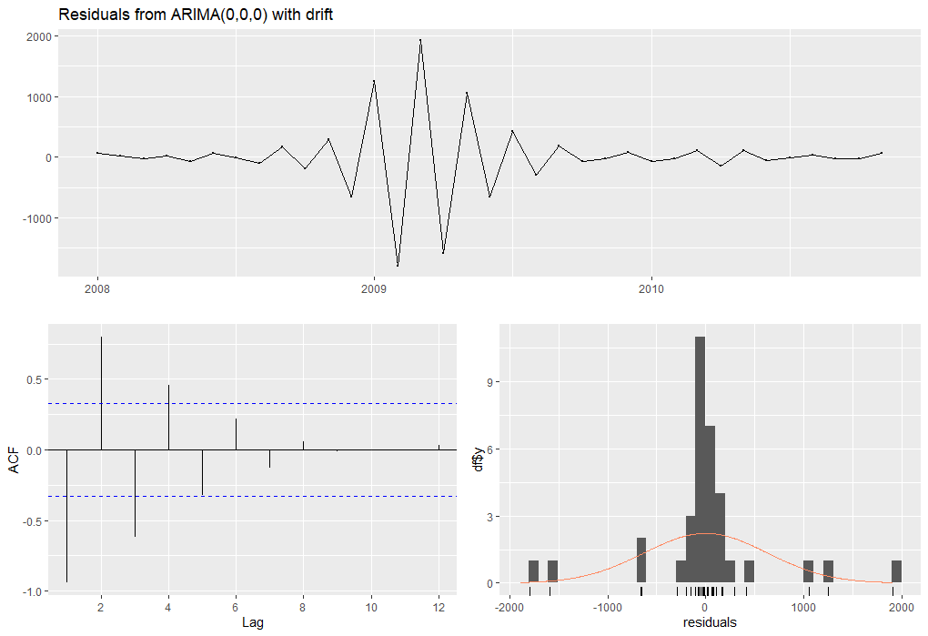

- ARIMA (4, 0, 0)
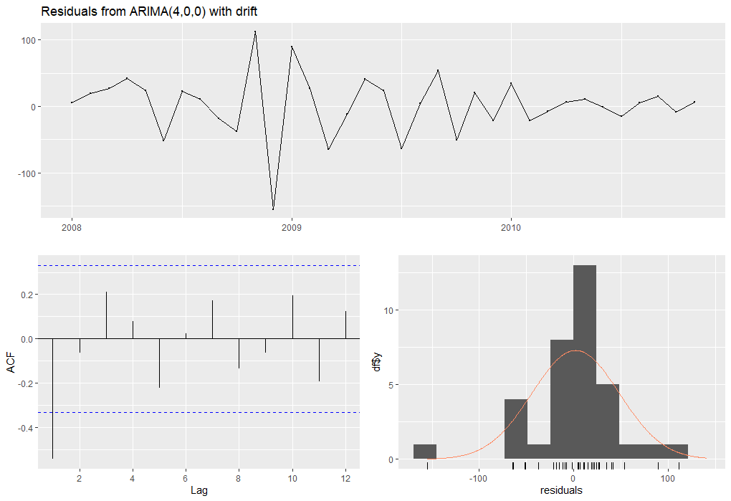

Next we forecast additive, multiplicative and ARIMA (5, 0, 0) model for the given time series data.

Forecast:

In this section we plot 12-month forecast i.e., from December 2010 to November 2011. Below are the plots for forecast of the classical and ARIMA models.
This forecast is done using function forecast. It takes two argument one is our time series model and the second argument is 'h', it specifies the number of values we want to forecast which is set to 12, in our case.
Below is the forecast of Holt winter additive and multiplicative model.

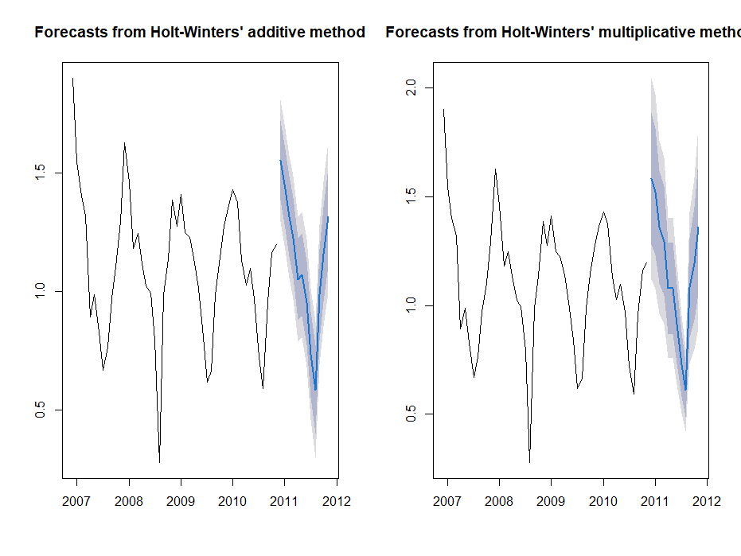
Forecast for Holts winter’s Additive Model and Multiplicative Model
Again after
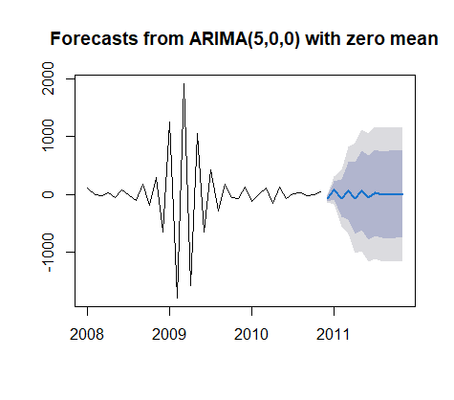
Forecast for ARIMA model
From the above plots, we can see that prediction bands are narrow for additive model as compare to other two models multiplicative model and ARIMA model.

 |  | Point Forecast | Lo 80 | Hi 80 | Lo 95 | Hi 95
Dec | 2010 | 1.552912 | 1.384869 | 1.720956 | 1.295912 | 1.809913
Jan | 2011 | 1.452465 | 1.284142 | 1.620788 | 1.195037 | 1.709893
Feb | 2011 | 1.316558 | 1.147609 | 1.485508 | 1.058173 | 1.574944
Mar | 2011 | 1.225447 | 1.05539 | 1.395504 | 0.965367 | 1.485526
Apr | 2011 | 1.051486 | 0.879713 | 1.223259 | 0.788782 | 1.31419
May | 2011 | 1.069823 | 0.895609 | 1.244037 | 0.803385 | 1.336261
Jun | 2011 | 0.951 | 0.773517 | 1.128483 | 0.679563 | 1.222437
Jul | 2011 | 0.734848 | 0.553185 | 0.916511 | 0.457018 | 1.012678
Aug | 2011 | 0.583584 | 0.396764 | 0.770404 | 0.297868 | 0.869301
Sep | 2011 | 0.985203 | 0.792207 | 1.178199 | 0.690041 | 1.280365
Oct | 2011 | 1.156339 | 0.956125 | 1.356554 | 0.850137 | 1.462541
Nov | 2011 | 1.315919 | 1.107439 | 1.524398 | 0.997077 | 1.63476

Forecast Values for Additive Model

 |  | Point Forecast | Lo 80 | Hi 80 | Lo 95 | Hi 95
Dec | 2010 | 1.5827165 | 1.279531 | 1.885902 | 1.119034 | 2.046399
Jan | 2011 | 1.5231729 | 1.231058 | 1.815288 | 1.076422 | 1.969924
Feb | 2011 | 1.36048 | 1.098896 | 1.622064 | 0.960422 | 1.760538
Mar | 2011 | 1.2964725 | 1.046068 | 1.546877 | 0.913512 | 1.679433
Apr | 2011 | 1.0786321 | 0.86885 | 1.288414 | 0.757798 | 1.399466
May | 2011 | 1.0793316 | 0.867347 | 1.291317 | 0.755128 | 1.403535
Jun | 2011 | 0.9145376 | 0.73257 | 1.096505 | 0.636242 | 1.192833
Jul | 2011 | 0.7290424 | 0.581582 | 0.876503 | 0.503522 | 0.954563
Aug | 2011 | 0.6115896 | 0.485392 | 0.737788 | 0.418586 | 0.804593
Sep | 2011 | 1.08182 | 0.853281 | 1.310359 | 0.732299 | 1.431341
Oct | 2011 | 1.1920139 | 0.933314 | 1.450714 | 0.796367 | 1.587661
Nov | 2011 | 1.3620737 | 1.057403 | 1.666745 | 0.89612 | 1.828028

Forecast values for multiplicative Model

The forecasted values above for both Additive and multiplicative model follow the same trend as our original time series data. The power consumption decreases from December 2010 to August 2011 and then increases at the end of year.

 |  | Point Forecast | Lo 80 | Hi 80 | Lo 95 | Hi 95
Dec | 2010 | -102.863347 | -145.239 | -60.4878 | -167.671 | -38.0555
Jan | 2011 | 111.935689 | -42.2228 | 266.0942 | -123.829 | 347.7008
Feb | 2011 | -108.809268 | -428.758 | 211.1398 | -598.129 | 380.5107
Mar | 2011 | 104.566814 | -383.781 | 592.9146 | -642.297 | 851.4303
Apr | 2011 | -100.057454 | -712.939 | 512.8242 | -1037.38 | 837.2642
May | 2011 | 87.751714 | -594.813 | 770.3161 | -956.141 | 1131.644
Jun | 2011 | -62.781841 | -778.011 | 652.447 | -1156.63 | 1031.066
Jul | 2011 | 30.765674 | -700.567 | 762.0984 | -1087.71 | 1149.243
Aug | 2011 | -4.573668 | -745.416 | 736.2687 | -1137.59 | 1128.447
Sep | 2011 | -6.163305 | -751.801 | 739.4745 | -1146.52 | 1134.191
Oct | 2011 | 2.299544 | -744.146 | 748.7452 | -1139.29 | 1143.89
Nov | 2011 | 7.240574 | -739.384 | 753.8652 | -1134.62 | 1149.104

Forecast values for ARIMA

The forecasted values ARIMA models is very fluctuating in all the moths, almost double the previous month or half like in Dec 2010 it is forecasted as -102.86 while in next month which is Jan 2011 it is positive 111.93.

